|  |
| --- |
| Written by: Ramin Kurkeice, Ahmad El-Hajj, Matthew Phillip |

Solar Panel Monitor By MARS

Computer Engineering Technology

# 

# Declaration of Joint Authorship

We, Ramin Kurkeice, Ahmad El-Hajj, and Matthew Phillip, we acknowledge that this work is submitted by the group work of all members and is expressed in our own words and work that is paraphrased accordingly. Any uses made within the work of any other author/ authors. Any uses made within it of the works of any other author, in any form (ideas, equations, figures, texts, tables, programs), are properly acknowledged at the point of use. A list of the references used is included. The work breakdown is as follows: Each of us provided functioning, documented hardware for a sensor or effector. Ramin Kurkeice provided the ZPT101B. Ahmad El-Hajj provided the current sensor. Matthew Phillip provided temp sensor. In the integration effort Matthew is the lead for further development of our mobile application, Ahmad is the lead for the Hardware, and Ramin is the lead for connecting the two via the Database.

# Proposal

We have created a mobile application, worked with databases, completed a software engineering course, and prototyped a small embedded system with a custom PCB as well as an enclosure (3D printed/laser cut). Our Internet of Things (IoT) capstone project uses a distributed computing model of a smart phone application, a database accessible via the internet, an enterprise wireless (capable of storing certificates) connected embedded system prototype with a custom PCB as well as an enclosure (3D printed/laser cut), and are documented via this technical report targeting OACETT certification guidelines.

Intended project key component descriptions and part numbers  
Development platform:   
Sensor/Effector 1: Lumosity sensor  
Sensor/Effector 2: current sensor  
Sensor/Effector 3: power sensor

We will continue to develop skills to configure operating systems, networks, and embedded systems using these key components to create the solar panel sensor and track info from the device and place it within the database. We plan on making the mobile application work with the intended design of the tracker and pull data from the device when needed. and make the device with the skills learned from the previous semesters such as CENG 251, CENG 254, CENG 322, and CENG 317 to effectively create a downsized prototype of the capstone and to make the necessary decisions and teamwork to create the work.

Our project description/specifications will be reviewed by, Dr. Dragos Paraschiv. They will also ideally attend the ICT Capstone Expo to see the outcome and be eligible to apply for NSERC funded extension projects..

The small physical prototypes that we build are to be small and safe enough to be brought to class every week as well as be worked on at home. In alignment with the space below the tray in the Humber North Campus Electronics Parts kit the overall project maximum dimensions are 12 13/16" x 6" x 2 7/8" = 32.5cm x 15.25cm x 7.25cm.

Keeping safety and Z462 in mind, the highest AC voltage that will be used is 16Vrms from a wall adapter from which +/- 15V or as high as 45 VDC can be obtained. Maximum power consumption will not exceed 20 Watts. We are working with prototypes and that prototypes are not to be left powered unattended despite the connectivity that we develop.

# Executive Summary

Business Need/Opportunity

Humber College Institute of Technology and Advanced Learning, Has installed 4 solar panels to the gazebo in the campus although unsure of how much power is being collected the MARSINC team as decided to work with Humber to created a prototype that would connect a database with the device and display reading on to the application.

This would bring interest in the Humber community two have visual proof of power collection and further inspire clean energy from the client and hopefully inspire more companies and businesses to implement similar technology.

What we hope to achieve is a framework to be built upon in the field of clean energy recording and data sharing.

Statement of Work

This effort includes the following:

Created Printed Circuit Boards (PCB) to house the wired components in as small as possible.

* Create and improve an encasing for the device that protects and improves portability.
* Make a mobile application that is simple, easy to use, and free to access.
* Create a database and store readings from the device to be retrieved from the application.

Contents

Declaration of Joint Authorship 3

Proposal 5

Executive Summary 7

List of Figures 11

1.0 Introduction 13

1.1 Scope and Requirements 13

2.0 Background 15

3.0 Methodology 17

3.1 Required Resources 17

3.1.1 Parts, Components, Materials 17

3.1.2 Manufacturing 17

3.1.3 Tools and Facilities 17

3.1.4 Shipping, duty, taxes 17

3.1.5 Time expenditure 17

3.2 Development Platform 17

3.2.1 Mobile Application 17

3.2.2 Image/firmware 19

3.2.3 Breadboard/Independent PCBs 19

3.2.4 Printed Circuit Board 21

3.2.5 Enclosure 22

3.3 Integration 23

3.3.1 Enterprise Wireless Connectivity 24

3.3.2 Database Configuration 24

3.3.3 Security 24

3.3.4 Testing 24

4.0 Results and Discussions 25

5.0 Conclusions 27

6.0 References 29

7.0 Appendix 31

7.1 Firmware code 31

7.2 Application code 31

# List of Figures

Figure 1. By Android Studio - https://developer.android.com/studio/, CC BY-SA 4.0, https://commons.wikimedia.org/w/index.php?curid=74094999 19

Figure 2. Initial schematic. This work is a derivative of "http://fritzing.org/parts/" by Fritzing, used under CC:BY-SA 3.0. 20

Figure 3. This work is a derivative of "http://fritzing.org/parts/" by Fritzing, used under CC:BY-SA 3.0. 20

Figure 4. Breadboard prototype. 21

Figure 5. PCB design This work is a derivative of "http://fritzing.org/parts/" by Fritzing, used under CC:BY-SA 3.0. 22

Figure 6. Humber Sense Hat Prototype PCB. 22

Figure 7. Example enclosure. 23

# Introduction

Mars is a small organization of students that are taking on this capstone project for Humber college institute of advanced learning and technology on the Solar panel monitoring of the solar panels on the gazebo. We are omitting the website application as we believe that the mobile application is more compact easy to access and can be ported to a website in the future. We are including a Lumosity sensor as well as a current and voltage sensor to calculate power and lux of the solar panel. We also are making a database that collects this information and adds it to the mobile application. We undertook this assignment as a way to help improve our skills and inspire companies to maintain solar panels. The problems we have are Humber is unable to access the database of the solar panels from the original installers and we must make one from scratch we believe this will set back our project but we are confidant in finishing the product.

## 1.1 Scope and Requirements

The solar monitoring system is an Internet of Things (IoT) capstone project that uses a

distributed computing model of a smart phone application, a web application, a

database accessible via the inter, an enterprise wireless (capable of storing certificates)

connected embedded system prototype with a custom PCB as well as a laser cut

enclosure, and is documented via an OACETT certification acceptable technical report.

The capstone project must be able to fit in the space below the tray in the Humber North

Campus Electronics Parts kit the overall project maximum dimensions are 12 13/16" x

6" x 2 7/8" = 32.5cm x 15.25cm x 7.25cm. Keeping safety and Z462 in mind, the highest

AC voltage that will be used is 16Vrms from a wall adapter from which +/- 15V or as

high as 45 VDC can be obtained. Maximum power consumption will not exceed 20

Watts. Android device must have a data visualization activity and action control activity.

CSA testing will not be done in this project. Database must collect data at a frequent

time and must be accessible through web and mobile application

The solar monitoring system is an Internet of Things (IoT) capstone project that uses a

distributed computing model of a smart phone application, a web application, a

database accessible via the inter, an enterprise wireless (capable of storing certificates)

connected embedded system prototype with a custom PCB as well as a laser cut

enclosure, and is documented via an OACETT certification acceptable technical report.

The capstone project must be able to fit in the space below the tray in the Humber North

Campus Electronics Parts kit the overall project maximum dimensions are 12 13/16" x

6" x 2 7/8" = 32.5cm x 15.25cm x 7.25cm. Keeping safety and Z462 in mind, the highest

AC voltage that will be used is 16Vrms from a wall adapter from which +/- 15V or as

high as 45 VDC can be obtained. Maximum power consumption will not exceed 20

Watts. Android device must have a data visualization activity and action control activity.

CSA testing will not be done in this project. Database must collect data at a frequent

time and must be accessible through web and mobile application

The solar monitoring system is an Internet of Things (IoT) capstone project that uses a distributed computing model of a smart phone application, a web application, a database accessible via the internet, an enterprise wireless (capable of storing certificates) connected embedded system prototype with a custom PCB as well as a laser cut enclosure and 3d print, and is documented via an OACETT certification acceptable technical report. The capstone project must be able to fit in the space below the tray in the Humber NorthCampus Electronics Parts kit the overall project maximum dimensions are 12 13/16" x 6" x 2 7/8" = 32.5cm x 15.25cm x 7.25cm. Keeping safety and Z462 in mind, the highestAC voltage that will be used is 16Vrms from a wall adapter from which +/- 15V or as high as 45 VDC can be obtained. Maximum power consumption will not exceed 20 Watts. Android device must have a data visualization activity and action control activity. CSA testing will not be done in this project. Database must collect data at a frequent time (every 30 minutes) and must be accessible through mobile application.

Report

/1 Hardware present?

/1 Introduction (500 words)

/1 Scope and Requirements

/1 Background (500 words)

/1 References

# 2.0 Background

We would like to thank our sponsor, Dr. Dragos Paraschiv from Humber institute of advance learning and technology for supporting this project. Solar panels monitoring has been a part of the process for solar panel instillation for years. We believe that the system in place for solar panel monitoring is help with companies who are carbon footprint conscience to manage the steady supply of power and Lumosity to properly understand and quality check the solar panels that were installed. According to the Ontario solar installers they state that when a solar panel is installed it isn’t ideal to have it running and move on with your day as it is important to have monitoring of the solar panel because it can help with checking of quality of energy from time to time as well is making sure everything is working correctly. (Ontario Solar Installers, 2019). Thus we use monitoring when solar panels are installed to check the proper Lumosity input on a certain day for example a sunny day should yield more power although we check the monitoring software and find that the Lumosity is lower than expected we can then cross examine the sensors and fix the problem before a more expensive solution is reached. We are doing this capstone in response to Humber college institute of advanced learning and technology due to their mission statement that they would like to reduce carbon emission by a considerable amount every year. Humber college installed solar panels to the gazebo in the college grounds over the summer of 2019. Their goal was shaped by their recognition of clean energy and have won awards for their determination according to MediaCorp Canada Inc. They state that Humber college is one of four colleges that won the 2019 greenest employers award as they showcase a number of green features like water bottle stations, bio walls, PV solar panels, etc. (Yerema & Kristina , 2019). with this information Humber wanting to further green energy we are tasked to monitor these new solar panels. As stated above the importance of monitoring these solar panels is to make sure that clean energy is maintained for as long as possible. This can inspire more businesses to follow green energy as it holds a lot of benefits. RecSolar states that many expanding businesses invest in solar power as they take advantage of a new facility and infostructure this investment can also provide branding and community goodwill with the public for reducing carbon footprints and help with increase your total savings in energy storage. (RecSolar, 2017). These and more are the reason why we plan to take this capstone project and as we see the world is more conscious of green energy and reducing carbon footprints it is also very important that companies are responsible to monitor it as well to ensure quality in power management. These can benefit business in the future on power consumption, energy storage, and reduce cost. Thus our capstone’s goal is to help inspire organizations to maintain quality of solar panels.

# 3.0 Methodology

Our methodology of the Solar panel senor for Humber institute of technology and advanced learning was to use the agile method for our project management we created Gantt charts for both the software and hardware components we in the middle of the work had problems that delayed our progress for example pcb were faulty on the first few attempts and major bugs in our code that took longer to find and fix than expected.

Although using the agile method was the most efficient way of getting this capstone project done.

## 3.1 Required Resources

Below we discuss the required resources in this capstone project. We will explain the parts components and materials that were used and their specifications. We will later talk about manufacturing where we discuss the PCB (Printed Circuit Board) and the Encasement of the devices. Next, we will mention tools and facilities which were the tools, resources, software’s, and facilities we worked with and in with how each one was used for in our project. Later we will explain the shipping duty and taxes that came with the production period of the devices will we used 3rd party manufactures’ we explain the cost and taxes and the explanation of possible duty fees that could arise. Finally we talk about time expenditure which will discuss the leading time and work time in our project.

Report

/1 Parts/components/materials (500 words)

/1 PCB, case (500 words)

/1 Tools, facilities (500 words)

/1 Shipping, duty, taxes (250 words)

/1 Working time versus lead time (250 words)

### 3.1.1 Parts, Components, Materials

This capstone project requires key components to produce such as (1) Raspberry pi 3 model B, (2) ACS 712 current sensor, (3) ZMPT101B voltage sensor, and (4) LM 35 temperature sensor. This project will run on a Raspberry pi 3 model B which is a microprocessor. The Raspberry pi contains a total of 40 pins to operate with. The pins we need are the 3v3 pin, GPIO2 and GPIO3, and the ground pin. The ACS 712 is a current sensor that measures the current in amperes of the following input and exports it in an analog output, its max readings are 5A. Since the we need to be able to read the data, we will need an Analog to Digital Converter (ADC). The type of ADC used in this project is the ADS1115. The ADS1115 contains 4 analog channels to convert, an alert/ready, address pin, an I2C SDA pin, I2C SCL pin, ground pin and a voltage pin that needs 2.0 to 5.5 volts. The ZMPT101B is a voltage sensor that measures the inputs voltage. The supply voltage ranges between 5 to 30 volts and can measure AC voltage within 250 volts. The ZMPT101B has a total of 6 pins. Two for the input which is the Neutral and Phase. It contains a voltage power source and an analog output pin and 2 ground pins to displace the voltage. The output of the produces and analog output which will require an analog to digital converter as well. The previous ADC used will work on a different analog channel pin since it reads a total of 4. The Lm35 is a temperature sensor that will measure the temperature of the sensor in Celsius. The LM35 consists a voltage pin and a ground pin and a Vout pin which outputs the readings in an analog form. PCB sheets are required to create an interrogated PCB with the following sensors. PCB sockets are needed to help connect all sensors and parts to each other under one PCB, making it safer and easier to enclose. The following socket pins needed is a 6pin 3 by 2 for the raspberry pi pins, 10 pin 10x1 for the ads1115 analog to digital converter, two 3 pin 3x1 for the ACS 712 current sensor and the LM 35 temperature sensor, and a 4 pin 4x1 for the ZMPT101B voltage sensor. Soldering wires are necessary to successfully connect pins to the PCB boards. A Velamen Solar Cell is needed to create power so we can read and measure it. It contains a max of 1 volt and 200 milliamperes. We will be switching from the LM35 to the Lumosity sensor of a mini solar panel this is done due to an agreement that temperature will be found through the weather apk in our mobile app instead from an analog to digital reading this will reduce the PCB wiring cost as we already are supplied a Lumosity sensor and reduce the size of the PCB This will also reduce the power consumption of the Raspberry pi 3 b.

### 3.1.2 Manufacturing

Sensor/Effector 1: ACS 712 Current

Sensor/Effector 2: ZMPT101B Voltage

Sensor/Effector 3: LM35 Temperature

Ramin Kurkeice worked on the PCB (Printed Circuit Board) for the sensor zmpt101b the PCB was designed using a software called fritzing it was made after a breadboard wiring he made and once it was created digitally the computer generates a schematic and a PCB design he then spent most of his time fixing the schematics to be more readable and follow the guidelines. Also there was extra time spent for the redesigning the PCB as there were some shorts and how to incorporate PCB sockets to reduce space. The files used were then printed to have 3 sockets a 10 pin for i2c, 6 pin for the pi, and a 4 pin for the voltage sensor. They were wired with a resistor in mind. Ramin Has also used Inkscape software for SVG editing to create an encapsulation for the pi He would then save the scalable vector image as a pdf for laser cutting the software used for laser cutting was Corel draw that pulled the pdf image and follows it with the laser the case was clear acrylic and was designed with green outline for pieces and red outline for cutting holes into those pieces. There was a total of 6 pieces which all connected like a puzzle. Ahmad used a software called fritzing to create his PCB with the following breadboard image , design schematic and PCB design was rechecked for the proper design found used 3 sockets for the pi i2c and the current sensor. The case was made with open AutoCAD and cura to make the 3d model of the raspberry pi 3 b case. It was later printed and took about 8 hours of inconsecutive prints. And used PLA grey as the printing material. Matthew Phillip worked on the PCB and case design for the DS18B20 temperature sensor, which was simple design because there was not too much material to insert to the PCB board. To create the breadboard, schematic, and PCB design the platform that was used is called fritzing. On the PCB board Matthew Phillip made sure the dimensions of the via were 1.0mm for hole diameter and the ring thickness was 0.5mm. Then Matthew added the DS18B20 temperature sensor with three appropriate vias so the sensor can fit into the PCB board. After that a 4.7k resistor was added with two appropriate via holes so the resistor can fit snuggly in the PCB. Finally, five vias was added in the suitable position and size so the raspberry pi can be inserted into the PCB board. Matthew Phillip designed the case by using a laser cutter in the prototype lab in humber college. The case was based on a design on a web application called Thingiverse with modifications using the platform called CorelDRAW X7. The modifications were made to make sure that the raspberry pi, the PCB, and the temperature sensor can all fit conformable in the case.

### 3.1.3 Tools and Facilities

During our 4 months of development on the prototype of this capstone we used a series of tools that were instrumental in the project success and development. We started working on both the hardware and software of the project immediately although we did not start working with hardware until a few weeks of planning and recording data in the first month we used Android Studio for the production of our mobile application we used the java programming language and used SQLite for the database as it is an easy to understand and pull from program. We also used Microsoft word for the writing of our proposals and reports, software such as Microsoft excel for our budget, and Gantt chart for the project planning in the agile method where had goals to reach each week in the semester. We later used the software Fritzing for PCB (Printed Circuit Board) planning and developed a connected circuit diagram, a schematic, and a PCB that is to be sent to print. The facilities we used other than our own homes were the Humber labs we had access to the workshops and were able to send our PCB to be printed there. We also used their labs write our code and learn new method to enhance the project. We used two different software for the encapsulation be the prototype members we used both Cura (3D printing design software) and Inkscape (Scalable Vector Image editing software) for the development of a 3D printed case and a laser cut case. Each case came with pros and cons from the software used. We then GitHub Desktop for easy push and pull from our project to be displayed for the public viewing. We also used GitHub’s markdown language to write a page for our project progress and a readme to describe the step by step instructions to create the device yourself. We developed in a secure location using Humber Institute of Learning and Advanced Technology internet environment as it requires valid certificate before having access to the Wi-Fi this ensures a protected device during development to avoid any malicious code from being implemented and having less of a security breach through the Bluetooth devices we used. We used the idea lab in Humber to use their 3d printers for our cases, we also used the laser cutter from the Humber workshop to make the other case. We used soldering irons and reverse soldering pump from the Humber labs to solder our PCB’s. we used PCB sockets to be solder onto the PCB so the connection to the sensors will not be permanent. We used power supplies and a frequency display to test our sensors we also used a raspberry pi 3 B as the microcontroller of the project. The minor tools used were our breadboard, wires, resistors, they were used for testing our connections and sensors, we used analog to digital converters for the converting of the analog voltage to digital data. For minor software used we used a Weather online apk that was used in our mobile app to display the weather. We also used WhatsApp to communicate with team members and emailed each other for documents needed and such.

### 3.1.4 Shipping, duty, taxes



 !"# $!%

&$ ! '(("$% #)*

 $" "+,%

-./ +%$+

*)0

*1 2/33!"!45*)0/ *6&*)$*$ 

! '(("$% 774*8 $

" "+,%-./

 +%$+

9: "

;,!"< "$ *)94$$

 ! '%$ $+= $"

 "+,%-./ +

%$+

The first sensor that was shipped, was the DS18B20, which is a sensor used to measure temperature. Matthew Phillip bought the SunFounder DS18B20 Temperature sensor Module for the raspberry pi and r3 from the online web application amazon and amazon got it from a company called SunFounder CA. The total cost for the product shipping and handling came up to $10.68 and the product took two days to ship. the GST/HST was included with the price. The duty for this product was not applicable as it was from a local retailer.

The second sensor that was shipped, was the ACS 712, and this sensor is used to measure current. Ahmad El-Hajj bought the RoboJax ACS712 Hall Affect 30A Current Sensor for Arduino from the Sayal store and other parts from online web application amazon. The cost of the sensor is $14.50, another product was the mini solar panel which costed $7.95, and the soldering kit 34.98. The total cost for the product shipping and handling came up to $0.00 as amazon has free delivery for orders over $35.00 and the product took one day to ship through amazon prime which came unprotected outside till I had to pick it up also the sensors costed around $5.00 worth of gas as I purchased it from Sayal . the GST/HST also came up to $7.57. The duty for this product came up to $0.00 due to not having any tariffs on the products I ordered.

The third sensor that was shipped, was the ZMPT101B, and this is a sensor used to measure voltage. Ramin Kurkeice bought the Voltage Transformer Module AC Sensor ZMPT101B J1 for the Arduino from the online web application eBay and for a low price of $3.60. I also bought the i2c digital coveter which was $3.45 and for testing I bought male to female wires $11.95 and PCB sockets $9.99 The total cost for the product shipping and handling came up to $20.00 and the product took seven days to ship. The total with GST/HST also came up to $29.07. The duty for this product came up to $0.00 due to no tariffs on these products and coming from Canadian companies.

### 3.1.5 Time expenditure

The lead time for our parts where not that large as the products were already in stock as we ordered we do acknowledge that the lead time for our PCB prints and 3d prints were large and the total was 8 days and 8 hours of lead time for the product shipped and product created. The work time to complete the whole project should take up to 4 months maximum because that’s when the project is due and we have to work on things like parts, components, materials, tools, facilities, and shipping and to collect all the parts, components, and materials should spawn of 30 minutes to 2 hours maximum but the lead time should take up to three days because of shipping. The PCB should be done with a spawn of one to two weeks because we as a group have to make a PCB design that fits all of our components on the board with no problem. We also have to trim any extra wire and solder down the components. The case will have a lead time of one week because we have to first design an appropriate case that can fit all the necessary parts, components, and materials in it. We also have to use a 3D printer or laser cutter to make the case, so the work time will take about one to 3 days. For the Tools the work time and lead time will be very low because we can borrow all the tools we need from the parts crib. The facilities should also have a low lead and work time because we can use most facilities like the parts crib, and the prototype lab for laser cutting, 3D printing, and for tools. The work time will also increase because we have to have team meets discuss about how the project is going and what’s the next step.

## 3.2 Development Platform

The development platform will include an in-depth analyzation of our mobile application, which will discuss the data visualization, action control, and login activity. Next we will talk about the image and firmware, discussing how the code can be accessed and run, if the hardware is wireless, and code distributed in the repository, finally we will talk about the breadboard / PCB design, pictures, and enclosure.

### 3.2.1 Mobile Application

The mobile application was made using the program android studio, which at this current stage in our development it is only available on android devices using software marshmallow and above. This means worldwide we have a huge market to reach instead of the other platforms we could have chosen. This app was programmed in the java language. We split this app in 3 parts. The front end, which was the layout of the app, the design of the colors, and the icon shown. The back end, which was the database used, and pulling and pushing records. The functionality, which was the code used to have navigation, code used to alter the front end. This was done with all members of this group participating in all three parts with leads for each part to help with the process to be developed more smoothly. The current status of the app is still requiring a better database as we used firebase to create a temporary database, what we discovered was that what we wanted to use for creating graphed data from records of certain times was much more difficult to create using the JSON format firebase uses. Thus we plan on going to finish the database with SQLite as this program uses the table format for holding records which we find will fit the functionality we are trying to achieve more efficiently. The app works using a login activity which was made using serial number tracking as a traditional login was not necessary for the scope of this project. We decided a serial number was best as if there were multiple devices the user would only want data from there device a not from all devices in the database. This was done by having the main page having a nine-digit password asking for the serial number of the device. (see figure 1). Once entered there will be a toast alert confirming or denying the serial number. Then when navigating you will see two data displays the readings page (see figure 2) this will display the current data that was updated in the database, and the history (see figure 3) this will display all the data from the entire day. (this is currently work in progress). You can see an info page (see figure 4) this will have the information describing what lux is and what the readings mean. There is a weather page that will prompt a permission from the user to use the GPS to find the weather in that area. (see figures 5 and 6). The navigation drawer has the following minor pages a blog which explains the app development and testcases, and settings which will change the apps design (see figure 7).

Figure 1-serial number

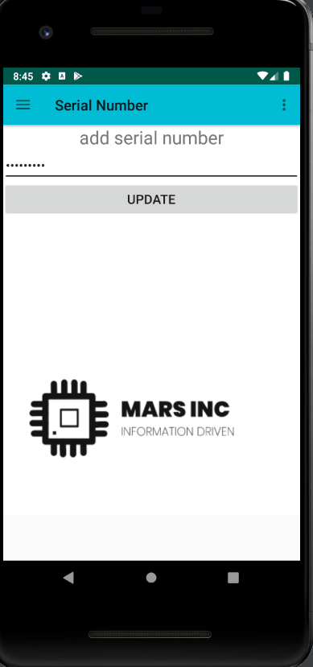

Status

/1 Hardware present?

/1 Memo by student A + How did you make your Mobile Application? (500 words)

/1 Login activity

/1 Data visualization activity

/1 Action control activity

Include screenshots such as Figure 1. Testing. Progress.

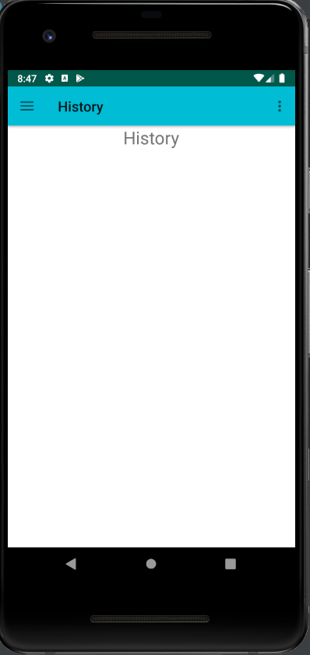Figure 2-Readings

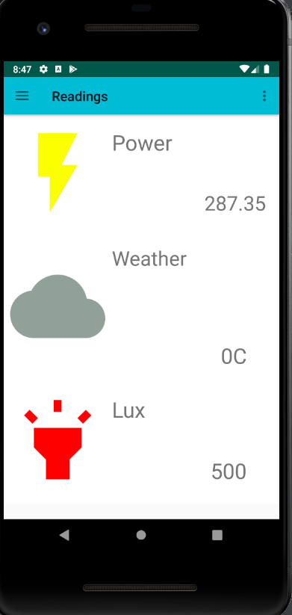

Figure 3-history WIP

Figure 4-info page

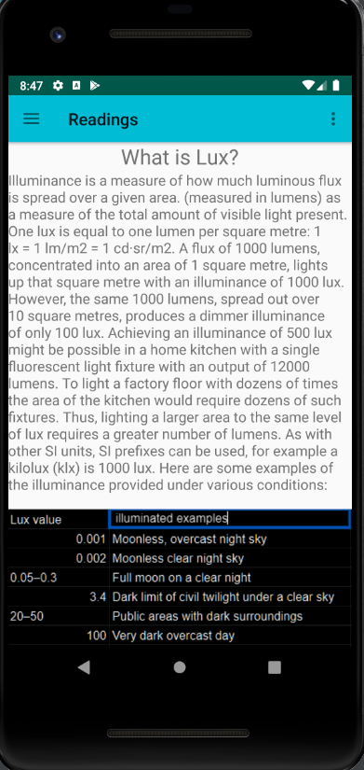

Figure 5-Weather permission

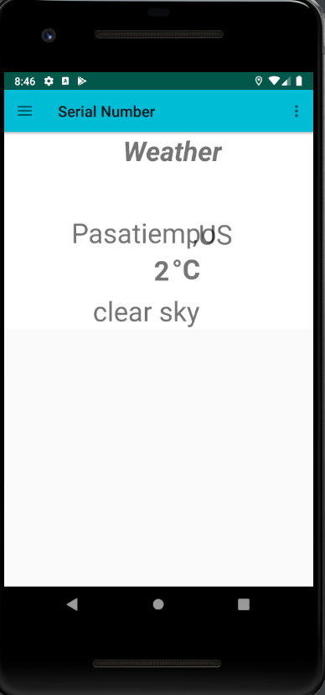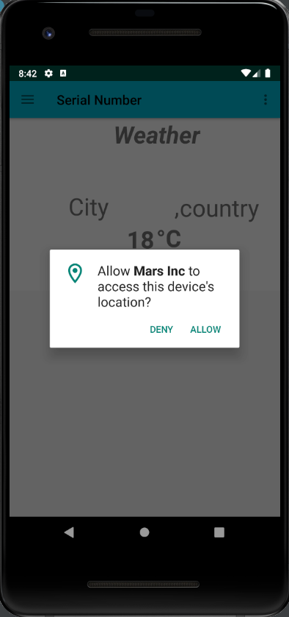

Figure 6- weather

Figure -setting and navigation

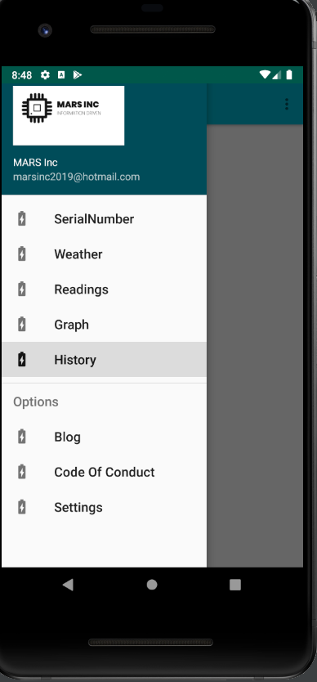

### 3.2.2 Image/firmware

Status

/1 Hardware present?

/1 Memo by student B + How did you make your Image/firmware? (500 words)

/1 Code can be run via serial or remote desktop

/1 Wireless connectivity

/1 Sensor/effector code on repository

### 3.2.3 Breadboard/Independent PCBs

Status

/1 Hardware present?

/1 Memo by student C + How did you make your hardware? (500 words)

/1 Sensor/effector 1 functional

/1 Sensor/effector 2 functional

/1 Sensor/effector 3 functional

The initial schematic design, Figure 2, based on datasheets (Bosch Sensortec, 2019) led to a breadboard layout Figure 3 that was realized Figure 4.

How did you build your Prototype: Breadboard?

Then a PCB was designed, Figure 5, and populated (Figure 6). Bill of Materials, Case, Time commitment. Testing. Progress.

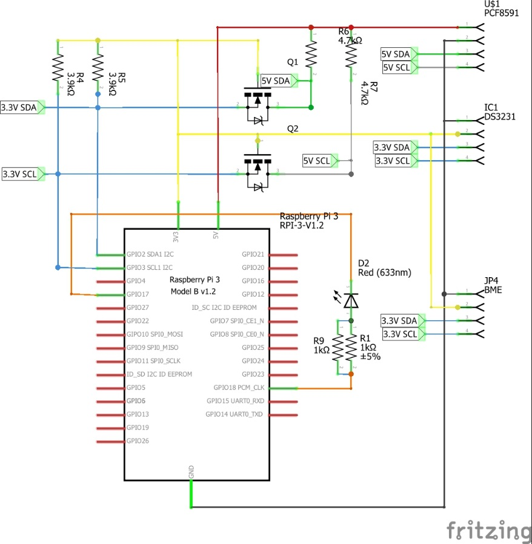

Figure . Initial schematic. This work is a derivative of "http://fritzing.org/parts/" by Fritzing, used under CC:BY-SA 3.0.

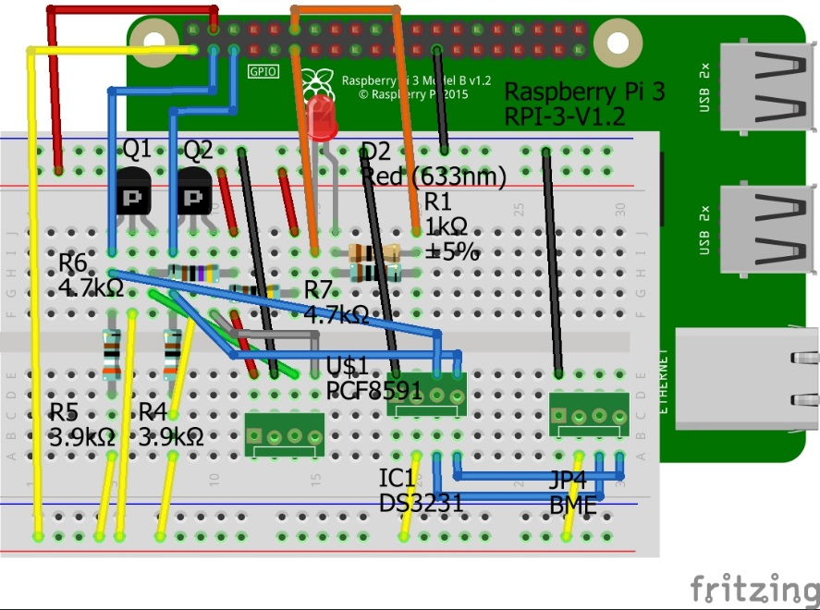

Figure . This work is a derivative of "http://fritzing.org/parts/" by Fritzing, used under CC:BY-SA 3.0.

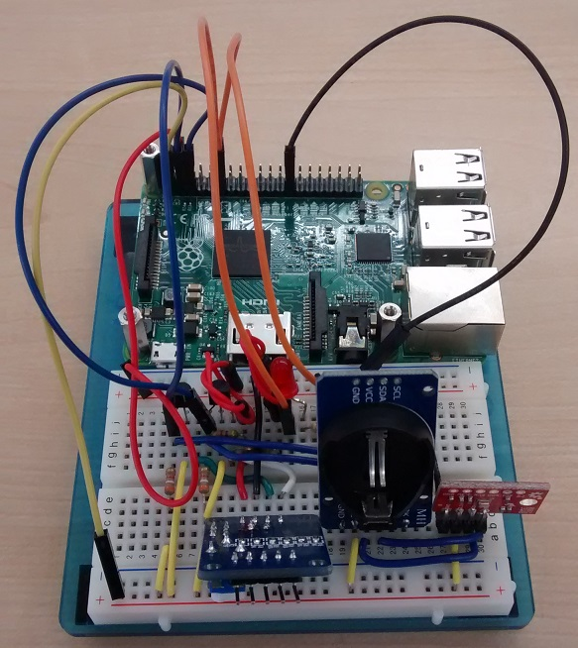

Figure . Breadboard prototype.

### 3.2.4 Printed Circuit Board

Demo

/1 Hardware present?

/1 PCB Complete and correct

/1 PCB Soldered wire visible but trim, no holes or vacancies

/1 PCB Tested with multimeter

/1 PCB Powered up

How did you build your Prototype: PCB?

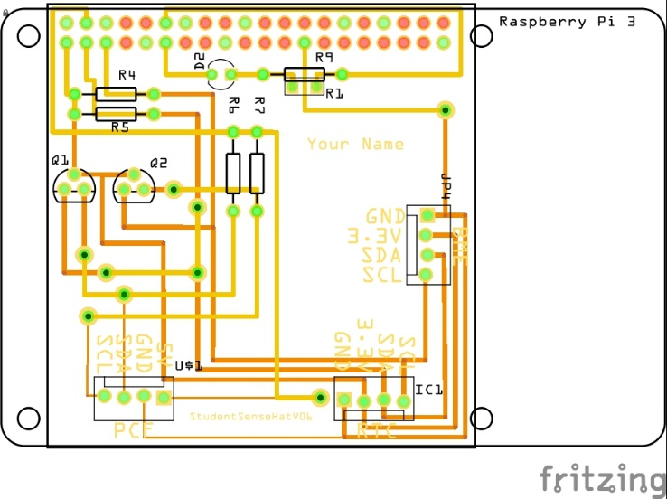

Figure . PCB design This work is a derivative of "http://fritzing.org/parts/" by Fritzing, used under CC:BY-SA 3.0.

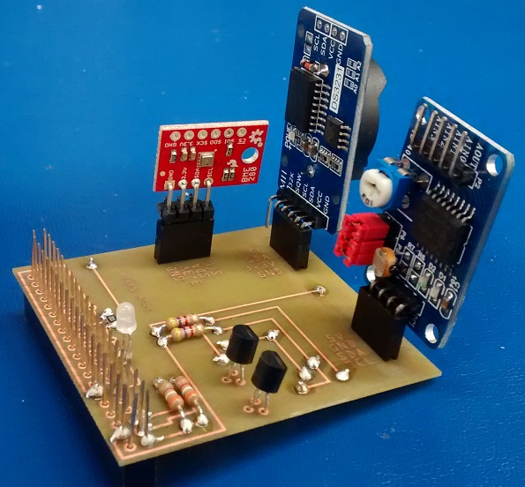

Figure . Humber Sense Hat Prototype PCB.

### 3.2.5 Enclosure

Demo

/1 Hardware present?

/1 Case encloses development platform and custom PCB.

/1 Appropriate parts securely attached.

/1 Appropriate parts accessible.

/1 Design file in repository, photo in report.

How did you build your Prototype: Case?

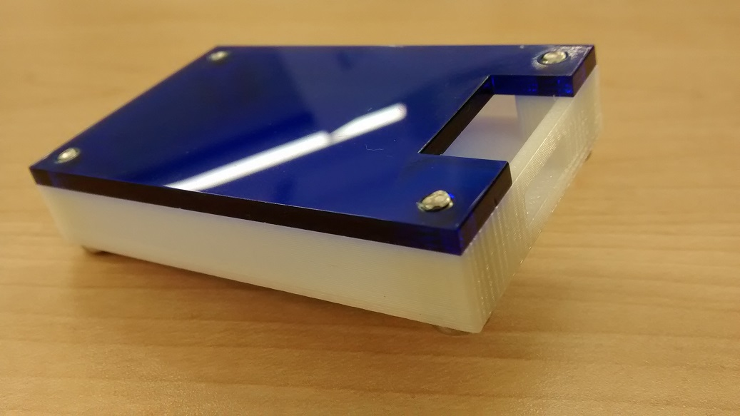

Figure . Example enclosure.

## 3.3 Integration

Demo

/1 Hardware present?

/1 Data sent by hardware

/1 Data retrieved by mobile application

/1 Action initiated by mobile application

/1 Action recieved by hardware

Report

/1 Enterprise wireless connectivity (250)

/1 Database configuration (250 words)

/1 Security considerations (500 words)

/1 Unit testing (900 words)

/1 Production testing (100 words)

### 3.3.1 Enterprise Wireless Connectivity

How did you make a Database accessible by both your Prototype and Mobile Application?

### 3.3.2 Database Configuration

### 3.3.3 Security

### 3.3.4 Testing

Unit testing and Production testing.

# 4.0 Results and Discussions

Is your prototype perfect? What did you learn?

# 5.0 Conclusions

If you were making 1000 of these.

Report

/1 Hardware present?

/1 Checklist truthful

/1 Valid Comments

/1 Results and Discussion (500 words)

/1 Conclusion

# 6.0 References

Bosch Sensortec. (2019, July). *BME680 - Datasheet.* Retrieved from Robert Bosch GmbH: https://ae-bst.resource.bosch.com/media/_tech/media/datasheets/BST-BME680-DS001.pdf

Ontario Solar Installers. (2019, march 25). *Why do you need a Solar Monitoring*. Retrieved from Ontario solar installers.ca: https://ontario-solar-installers.ca/solar-panel-installers/why-do-you-need-a-solar-monitoring-system/

RecSolar. (2017). *solar for business*. Retrieved from Recsolar.com.

Yerema, R., & Kristina , L. (2019, april 14). Humber college recoginzed as one of canada's greenest employers. *canadastop100*, 1.

# 7.0 Appendix

## 7.1 Firmware code

Demo

/1 Hardware present?

/3 Code runs concurrently for all sensors/effectors

/1 Project repository contains integrated code

Status

/1 Memo including updates

/1 Financial update

/1 Progress update

/1 Modified Code Files in Appendix

/1 Link to Complete Code in Repository

## 7.2 Application code

Demo

/1 Hardware present?

/1 Memo by student A

/1 Login activity

/1 Data visualization activity

/1 Action control activity

Report

/1 Login activity

/1 Data visualization activity

/1 Action control activity

/1 Modified Code Files in Appendix

/1 Link to Complete Code in Repository